BSSE FINAL PROJECT
Agile Software Design Specification

PetLink



Product Owner

Zupash Awais

Presented by:
Group ID: S26SE025

Student Reg# Student Name

Faculty of Information Technology & Computer Science

University of Central Punjab

Agile Software Design Specification

SDS Phase II

Version 1.0

Product Owner

Zupash Awais

Scrum Master

Nabeel Ijaz

S26SE025

Team
Member Name | Roles
Nabeel Ijaz | Backend Development
Umar Akram | Web Development
Usama | Database Design and Testing
Ehsan Shahid | Mobile App Development

Table of Contents
Table of Contents i
Revision History & Sprint Log ii
Previous Phases Feedback ii
Abstract iii
1. System Architecture 1
1.1 High-Level Architecture 1
1.2 Architecture Diagram 1
1.3 Component Overview 1
2. Mapping Design to User Stories 2
3. Detailed System Design 3
3.1 Module Decomposition 3
3.2 Data Flow Description 3
4. UML Diagrams 4
5. Database Design (ERD) 5
5.1 ER Diagram 5
5.2 Schema Tables 5
6. API Design 6
7. UI/UX Design (Prototypes) 7
8. Sprint-wise Design Evolution 8
9. Test Design 9
10. Design Quality Attributes 10
11. Deployment Considerations 11
12. Future Enhancements 12
13. Revised Project Plan 13
14. References 14
Appendix A: Glossary 15
Appendix B: IV & V Report 16

Revision History & Sprint Log
Version | Sprint | Date | Changes | Owner

Previous Phases Feedback

Idea Defence Feedback (Screenshot)
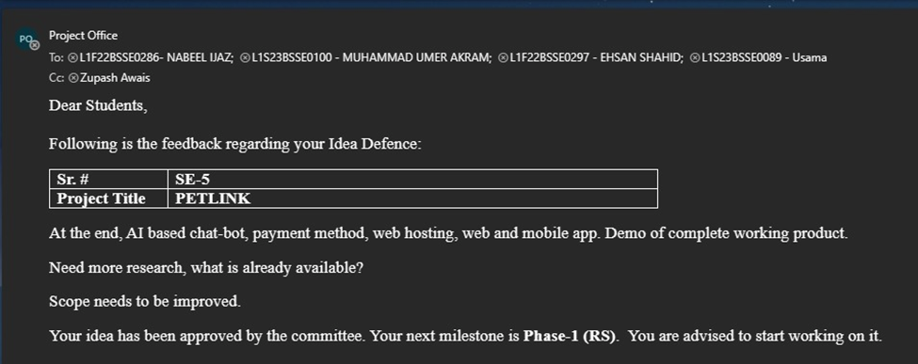

Abstract
PetLink is a cross-platform web and mobile application developed to serve as a comprehensive pet management platform. It provides a centralized digital solution for pet owners, adopters, buyers, and small service providers in Pakistan, enabling them to manage all pet-related activities through a single, user-friendly system.

In today’s fragmented environment, pet owners face significant challenges when they want to sell or adopt a pet, arrange temporary shelter during travel, purchase pet products, or maintain accurate health records. Most activities are currently handled through scattered social media groups, informal WhatsApp listings, or separate unconnected websites. This leads to incomplete information, lack of trust, difficulty in tracking vaccination schedules, unreliable service coordination, and increased risk of missing important pet care deadlines.

The proposed system offers a complete set of functionalities including user and pet profile management, pet adoption and sale listings with proper validation, temporary shelter service requests, an integrated pet product store with secure payment gateway, digital pet health and vaccination record management with automated reminders, Google Maps-based nearby veterinary clinic locator, and a custom AI-driven chatbot for instant user assistance and guidance.

By addressing these issues, PetLink fulfills a vital public need in the growing pet ownership community of Pakistan. It improves pet welfare through better record-keeping and timely care, enhances trust and transparency in pet trading and services, reduces fragmentation in the market, and provides a reliable, accessible platform that brings convenience and organization to thousands of pet lovers and service providers.

System Architecture

High-Level Architecture
<Identify the "style" of your system. Is it Client-Server (like a basic website), Microservices (independent small services), or Layered (Presentation, Logic, Data)? Briefly justify why you chose it.>

Architecture Diagram
<Insert Diagram here, Provide a visual map showing the big pieces (Frontend, Backend, Database, External APIs) and how they connect.>

Component Overview
<List each components from your diagram/ system and give it a one-sentence job description>.

Mapping Design to User Stories

Story ID | Component | Description
US-01 / US-02 | Authentication Module | Verifies inputs, salts and hashes user passwords via bcrypt, and generates stateless JWT tokens for future requests.
US-05 | Pet Profile Module | Creates relational mappings inside the MongoDB document cluster tying unique Pet entries to their respective Owner's User ID.
US-06 / US-07 | Marketplace Module | Registers public data documents within the marketplace data collection with structural attributes indicating adoption or sales pricing.
US-08 | Marketplace Search | Compiles runtime search strings into active multi-field mongo search queries, filtering parameters like species, age, and breed without structural lag.
US-09 | Shelter Request Module | Logs specific time intervals and notes between a pet owner and an available shelter provider entry.
US-10 / US-32 | Payment & Order Engine | Interfaces with Stripe sandbox endpoints to execute electronic transactions, outputting immutable order records on success.
US-11 / US-12 | Digital Health Vault | Adds sub-document medical logs to specific pet profiles and flags upcoming chronological tasks for automated system reminders.
US-13 | AI Chatbot Adapter | Accepts query strings from the client app, forwards them to the AI engine with a structured prompt, and renders the reply
US-14 | Location Engine | Pulls latitude/longitude from client device sensors and maps surrounding veterinary clinic landmarks via Google Maps
US-17 to US-26 | Admin Management UI | Locks product ingestion forms behind explicit admin security routes, managing live store inventories and sales logs.

Detailed System Design

Module Decomposition
<Break the big components into smaller sub-modules. Explain what the Authentication, Data Processing, and API Layers specifically do>
Examples:
- Authentication Module
- Data Processing Module
- API Layer

Data Flow Description
<Describe how data moves through the system. For example: "User enters credentials -> Auth Module checks DB -> Token is returned to UI.">

UML Diagrams
- Use Case Diagram: Shows how different users (Actors) interact with the system functions. (optional)
- Class Diagram: The "skeleton" of your code. Show the objects, their attributes, methods, and how they relate (Inheritance, Association). (Mandatory)
- Sequence Diagram: Shows the step-by-step logic over time. For one specific action (like "Purchase Item"), show the messages sent between the User, Controller, and Database. ). (Mandatory)

Database Design (ERD)

ER Diagram
<A visual map of your database tables (Entities), the fields they contain, and how they link (e.g., One-to-Many).>

Schema Tables
<A technical table defining each field's data type/attributes (e.g., user_id : INT, Primary Key).>
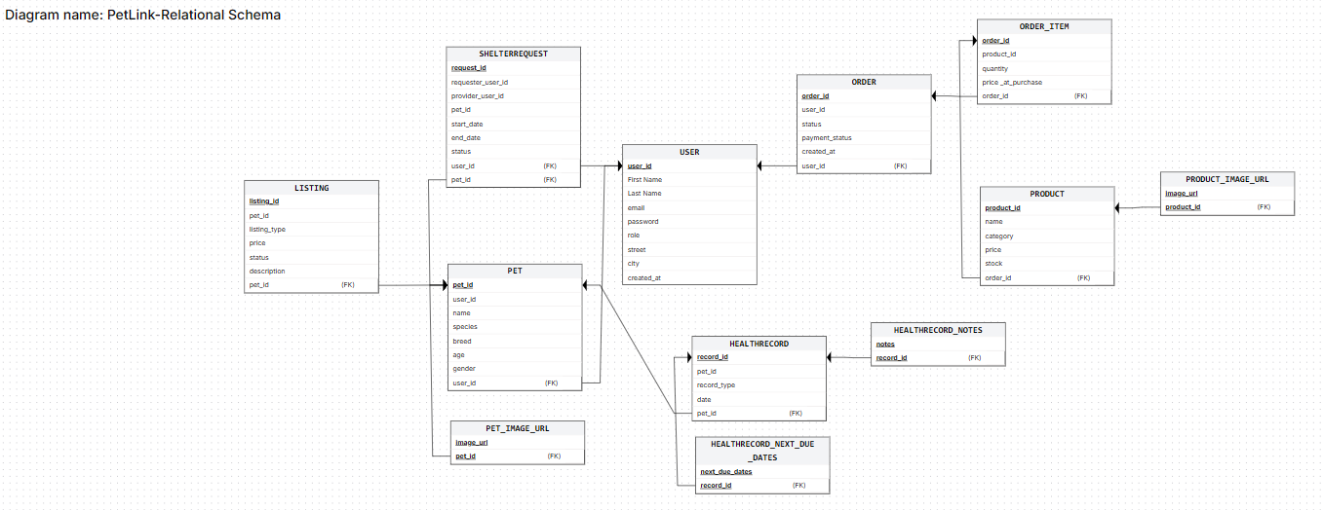

API Design

Endpoint | Method | Input | Output
/api/auth/register | POST | {name, email, password, role} | {success, token, user}
/api/auth/login | POST | {email, password} | {success, token, user}
/api/pets | POST | {name, species, breed, ageMonths, weightKg, imageUrl} | {success, petProfile}
/api/pets | GET | None | [petProfiles]
/api/listings | POST | Multipart Form Data | {success, listingId}
/api/listings | GET | query: `?type=sale&category=cat | [listings]
/api/shelters/bookings | POST | {shelterId, petId, startDate, endDate, notes} | {success, booking}
/api/shelters/bookings/:bookingId | PATCH | {status: 'Accepted'/'Rejected'} | {success, booking}
/api/products | GET | query: ?category=food&search=kitty | [products]
/api/admin/products | POST | {name, description, price, stock, category, imageUrls}` | {success, product}
/api/orders/checkout | POST | {cartId, shippingAddress} | {clientSecret, orderId}
/api/orders/confirm-payment | POST | {orderId} | {success, order}
/api/chatbot/message | POST | {message, sessionId} | {reply}
/api/clinics/nearby | GET | query: ?lat=31.5204&lng=74.3587 | [clinics]

UI/UX Design (Prototypes)
- Wireframes: Low-fidelity sketches (black and white boxes).
- Navigation Flow: A flowchart showing how a user gets from Screen A to Screen B.
- Screens: High-fidelity mockups (what the final app actually looks like).

Sprint-wise Design Evolution
<Describe how the design changed as you worked. "In Sprint 1, we designed the Login; in Sprint 2, we realized we needed an extra table for Social Media Auth, so we added it.">

Sample Table
Sprint | Features Designed | Improvements

Test Design
Goal: Plan how you will prove the system works.

What to write: Create specific scenarios.

- Scenario: "User enters wrong password."

- Expected Result: "System displays 'Invalid Credentials' error."

Sample test case table
Test ID | Scenario | Expected Result

Design Quality Attributes
<Explain how your design handles the "non-functional" stuff:>
- Scalability: How will it handle 10,000 users?
- Security: How are you protecting passwords (e.g., hashing)?
- Maintainability: How easy is it for a new developer to read your code?

Deployment Considerations
- Hosting: Where will it live? (AWS, Azure, Heroku?)
- Database: Which DB engine? (PostgreSQL, MongoDB?)
- Version Control: Mention using GitHub/GitLab and your branching strategy.

Future Enhancements
<What features did you want to include but didn't have time for? (e.g., "Add AI-based recommendations in Version 2.0").>

Revised Project Plan
<Show your progress and provide current status of the project in accordance with the plan provided in project proposal. Gantt chart should be used in this regard. Use Microsoft Office to develop the Gantt chart. Also provide an updated project plan.>

References
<List all books, conference papers, journal articles, websites, etc. used in preparing the content of this SRS. Provide enough information so that the reader could access a copy of each reference, including title, author, volume/edition number, page number(s), and publication year. Mention complete URLs for websites.>

Appendix A: Glossary
<Define all the terms necessary to properly interpret the SRS, including acronyms and abbreviations. You may wish to build a separate glossary that spans multiple projects or the entire organization, and just include terms specific to a single project in each SRS.>
Appendix B: IV & V Report
(Independent verification & validation)
IV & V Resource

Name Signature

S# | Defect Description | Origin Stage | Status | Fix Time
 |  |  |  | Hours | Minutes
1
2
3
…
Table 1: List of non-trivial defects

